**Jump statements**

Jump statements are used to alter the flow of control unconditionally. That is, jump statements transfer the program control within a function unconditionally. The jump statements defined in C++ are break, continue, goto and return. In addition to these jump statements, a standard library function exit () is used to jump out of an entire program.

**goto statement**

A goto statement can transfer the program control anywhere in the program. The target destination of a goto statement is marked by a label. The target label and goto must appear in the same function.

The syntax of a goto statement is

goto label;

label:

where label is an user defined identifier.

Example:

a=0;

start:

cout<<”\n”<<++a;

if(a<50) goto start;

prints numbers from 1 to 50.

**break statement:**

break statement skips the rest of the loop and jumps over to the statement following the loop.

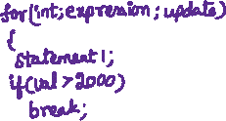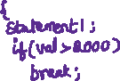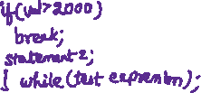

Example: #include<iostream>

using namespace std;

main()

{ int a,b,c,i;

for(i=0;i<20;++i)

{ cout<<"Enter two numbers";

cin>>a>>b;

if(b==0)

break;

else

c=a/b;

cout<<"\nQuotient="<<c<<"\n";

}

cout<<"\n Program over!";

}

**Output:**

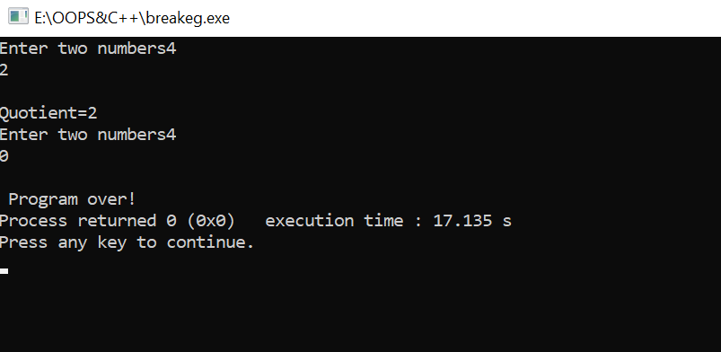

**The continue statement:**

The continue statement skips the rest of the loop statements and causes the next iteration of the loop to take place.

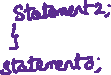

Example:

#include<iostream>

using namespace std;

main()

{

int a,b,c,i;

for(i=0;i<20;++i)

{

cout<<"Enter two numbers";

cin>>a>>b;

if(b==0)

{

cout<<"\n The denominator can not be zero\n"<<"Enter again\n";

continue;

}

else

c=a/b;

cout<<"\nQuotient="<<c<<"\n";

}

}

Output:

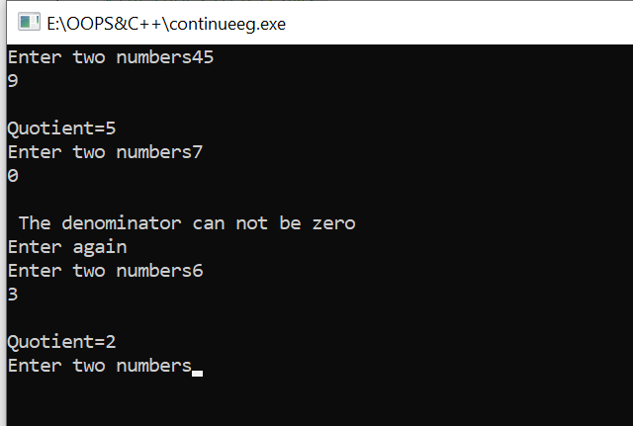

**The exit() function**

We can break out of a program using library function of c++, the exit() function.

**Example:**

#include<iostream>

#include<process.h>

using namespace std;

main()

{

int num,i;

cout<<"\n Enter the number";

cin>>num;

for(i=2;i<=num/2;++i)

if(num%i==0)

{

cout<<"\n Not a prime number";

exit(0);

}

cout<<"\n It is a prime number";

return 0;

}